County Councillor Update  Coker Division SCC  Cllr Mark Keating  March 2020 |  | 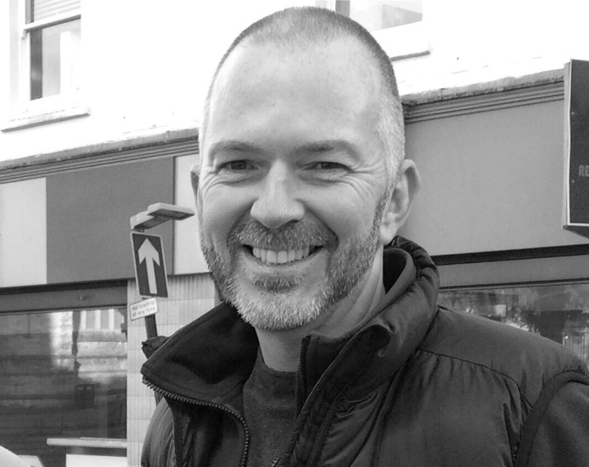
Representing you in - Barwick, Chiselborough, Closworth, East Chinnock, East Coker, Hardington Manderville, Hardington Marsh, Hardington Moor, Haselbury Plucknett, Middle Chinnock, Montacute, North Coker, North Perrott, Norton Sub Hamdon, ​Odcombe, Pendomer, Sutton Bingham, Stoford, West Chinnock, West Coker.
Useful Contacts Resources and Websites
Cllr Mark Keating – Somerset County Council | E: MAKeating@Somerset.gov.uk | M: 07767 203968
South Somerset Area Highways Office | E: countyroads-southsom@somerset.gov.uk | T: 0300 123 2224
Report Pothole/Road Defect | E: roadsandtransportSD@somerset.gov.uk | T: 0300 123 2224
Report Dead Animal/Mud on Road | E: roadsandtransportSD@somerset.gov.uk | T: 0300 123 2224
Neil McWilliams – Highways Service Manager | E: countyroads-southsom@somerset.gov.uk | T: 0300 123 2224
Lee Norman/Derek Davies – Assist Highways Service Manager | E: countyroads-southsom@somerset.gov.uk | T: 0300 123 2224
Garry Warren/Rebecca Vaughan – Traffic Engineer. Traffic & Transport Development | E: countyroads-southsom@somerset.gov.uk | T: 0300 123 2224
Gully Emptying / Road Sweeper | E: chris.holley@southsomerset.gov.uk | T: 01935 462462
Nick Allen – SSDC Ranger Scheme | E: nick.allen@southsomerset.gov.uk | T: 01935 462462
Road Records & Highway Licensing | E: Roadrecords@Somerset.gov.uk | T: 0300 123 2224

Report Adult at Risk | adults@somerset.gov.uk |  |  | T: 0300 123 2224  T: Emergency: 999
Report Child at Risk | childrens@somerset.gov.uk |  |  | T: 0300 123 2224  T: Emergency: 999
Children’s Social Care Worker out of hours Emergency Duty Team |  |  |  | T: 0300 123 2327
Fostering and Adoption www.fosteradoptsomerset.org.uk | AandFRecruitmentEnquiryLine@somerset.gov.uk |  |  | T: 0800 587 9900
www.somersetwaste.gov.uk |  | ssdc@southsomerset.gov.uk | T: 01935 462462
https://www.travelsomerset.co.uk/ |  | Travel - Drive Bus Train Walk Cycle Weather
www.somerset.gov.uk |  | generalenquiries@somerset.gov.uk | T: 0300 123 2224
http://roadworks.org/ |  | Useful website for road works info
www.facebook.com/somersetcountycouncil |  | Somerset County Council Facebook page
https://roam.somerset.gov.uk/roam/map |  | Interactive Rights of Way Map / maintenance reporting

Covid-19: Every winter our SCC’s Public Health and care professionals gear up for a busy winter in preparation for flu and norovirus, and now there’s a new virus – Coronavirus (or officially COVID-19). There are no positive COVID-19 cases in the South West, but SCC’s health and care services are well prepared with well-rehearsed plans in place to deal with any potential outbreaks. Covid-19 is believed to be spread from person to person through cough droplets. Simple basic hygiene measures (which we should be doing regularly anyway) can help prevent its spread. This includes washing your hands regularly with soap and water and using a tissue when sneezing or coughing and throwing it away – the familiar ‘catch it, bin it, kill it’. Without a tissue, then use the crook of your arm rather than your hand. For the latest information, advice and guidance, check out www.gov.uk/guidance/wuhan-novel-coronavirus-information-for-the-public
SCC Budget: SCC Councillors have approved a £338m budget for its services with robust financial plans in place across the next three years. No cuts to frontline services are planned and the Council has improved its financial resilience by increasing its levels of reserves. The ambitious budget included:
- £1.5m to be spent installing 20mph advisory zones outside around half of all Somerset’s schools with the remainder to follow in 2021.
- £133.5m to fund infrastructure projects, including new schools and school expansions, as well as highways and engineering.
- a significant £6.3m investment into social care providers to help fund the increased national minimum wage for care staff, as well as ensuring high quality provision
- £4.5m to introduce a Family Safeguarding model to better protect vulnerable Children in the County.
- £2m to provide better access to bus services for residents living in rural areas including three new Slinky buses, a further nine peak time bus services and faster, more direct services from West Somerset to colleges in Taunton.
- an undertaking to maintain the authority’s General Fund reserves, vital to financial stability, at the projected end-of-year figure of £19.69m across 21/22 and 22/23.
The budget plans will see more than £775 million spent on services in the coming year and a 1.99 per cent increase in the County Council’s element of the Council Tax. The government allows a further 2 per cent increase for Councils to provide Adult Social Care.
Climate Change Fund for Towns and Parishes: A massive £1m climate change fund has been created by SCC –the biggest single investment of its kind in the country. The £1m pot will be available for parish and town councils to bid for green initiatives in their own patch as SCC acts on its decision to sign the national Climate Change Emergency Declaration which aims to make Somerset carbon neutral by 2030 – with a commitment to find significantly more funding in the following years. More details will be published in the next few months with clear guidelines and governance.
One Somerset: Following his announcement in January, Somerset County Council Leader David Fothergill has now formally written to Robert Jenrick MP, Secretary of State for Housing, Communities and Local Government, kickstarting the case for One Somerset – A Unitary Council for Somerset. This follows an independent report commissioned by SCC and all four District councils which was published earlier this year and outlines clear benefits of switching to unitary. It is expected that around £25 million every year can be made available to reinvest and improve vital services by cutting waste and reducing duplication.
Brain in Hand: A digital helping hand is about to be trialled in Somerset to provide tailored support for people with mental health issues or learning disabilities. Brain in Hand is a personalised app that links the user with their carers and support teams. It provides people with their own specific ways to cope, with extra help on tap when needed. The app aims to increase a user’s independence by providing them with ways to manage their everyday life and negotiate a path that’s safe for them. It can give prompts and reminders and links to verbal responders or people’s own circle of support, who can intervene when asked, offering reassurance and the help needed to get back on track.
Childrens Mental Health: Somerset County Council is deploying two new teams to boost children’s mental health as part of its programme of support for children and schools available in the county. The initiative which has won £400,000 in Government trailblazer funding through the Fit for my Future partnership sees the Teams working in the Taunton and Mendip areas offering direct support to children and young people with mild to moderate mental health issues. The County Council, in partnership with Somerset CCG is now bidding for Government money to fund a wider roll-out of teams in Somerset. A decision is expected by September this year.
Utility Company prosecutions: Two utility firms have received significant fines after pleading guilty to roadwork’s offences. Somerset County Council brought action against Verizon UK Ltd and Western Power Distribution as part of its commitment to minimising disruption and keeping the public safe. Verizon UK Ltd pleaded guilty to one offence relating to unauthorised roadwork’s that led to substantial disruption on Taunton Road, Bridgwater and were fined £30,000 with £1,841 in costs. Western Power Distribution pleaded guilty to one offence relating to works in Kingstone, Ilminster which posed a real risk to the safety of the public and site operatives. They were fined £20,000 and ordered to pay £1,730 in costs.
Connecting Devon and Somerset: CDS has launched a fresh procurement to find new contractors to roll-out superfast broadband across the two counties. Working closely with Building Digital UK (BDUK) agency it follows confirmation of the Government’s funding extension for the programme– helping to provide a £38 million public investment in the region’s broadband.

